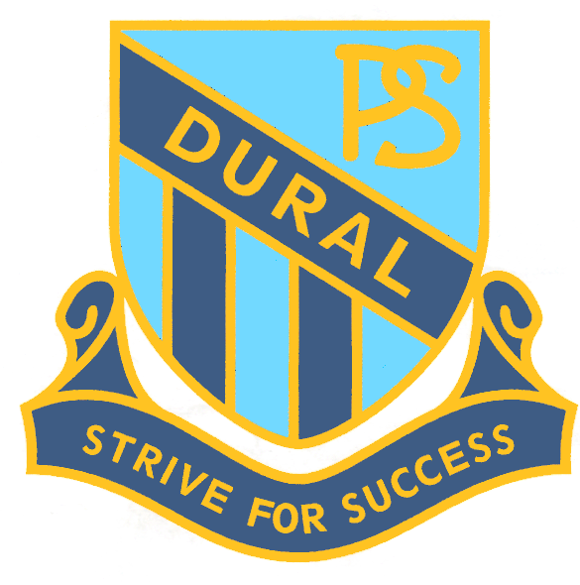
Dural Public School
Nutrition Policy - 2015

Rationale:
Healthy nutritional habits are essential to the growth and development of children.

Aims:
- To promote and model healthy eating within the school curriculum and all school programs.
- To develop in students an informed understanding and appreciation of healthy eating habits.
- To ensure that any foods provided by Dural Public School are consistent with the NSW Healthy School Canteen Strategy.

Guidelines:
Students:
- Students are encouraged to bring water to school in their drink bottles.
- Students will have access to their water bottles during class time and bubblers at recess and lunch times.
- Students will participate in the Crunch ‘n’ Sip initiative at 10.15am each day.
- Students will be encouraged to bring healthy food options in their lunchboxes.
- Students will not be permitted to share their personal food items with other children at school.
- Students will participate in nutrition education as part of the Personal Development, Health and Physical Education (PDHPE) key learning area.

Staff:
- Staff members are encouraged to model healthy eating habits whilst at school.
- Staff will refer to the Dural Public School PDHPE scope and sequence to guide their planning for nutrition education.
- Staff will teach nutrition education as part of the PDHPE Syllabus.
- Staff will reinforce healthy eating and good nutrition in all other teaching and learning activities.
- Consideration will be given to students who have or may have food allergies.

Parents/Caregivers:
- Parents/Carers will be encouraged to provide healthy food in their child’s lunchbox.
- Parents are encouraged to be considerate of food allergies within the classroom.

Implementation:
- Fundraising activities will focus on the promotion of healthy foods to compliment the learning taking place at school.
- The Dural Public School canteen utilises the NSW Healthy School Canteen Strategy when choosing menu items.
- The school canteen will promote healthy food options as part of the NSW Healthy School Canteen Strategy.
- Healthy food and drink options will be available to all students at offsite school activities, including excursions, camps and school functions.
- Parents will be regularly informed of healthy food choices and school nutrition initiatives via the newsletter.

